**UNEARTHING THE ENVIRONMENTAL IMPACT OF HUMAN ACTIVITY : A GLOBAL CO2 EMISSION ANALYSIS**

**1.INTRODUCTION**

**1.1 OVERVIEW:**

Co2 acts to trap heat in the Atmosphere, leading to Global Warming.

Development of strategies for improving industrial productivity by using novel

And sustainable forms of Energy in industrial production process. This will lead

to the increased sustainability of the Chemical Industry and provide support for

European Leadership in Co2 Re-use technologies.

**1.2 PURPOSE:**

Reducing Greenhouse Gas Emissions can improve air quality and save

Lives. The Carbon stored in natural sinks such as forests is released into the

Atmosphere through forest fire, changes in land use and logging.

**2. PROBLEM DEFINITION & DESIGN THINKING**

**2.1 EMPATHY MAP:**

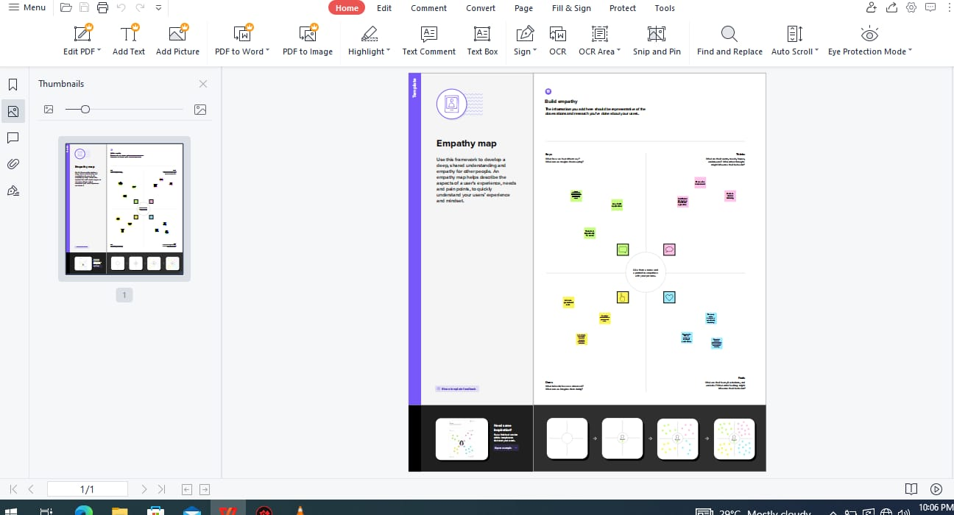

**2.2 IDEATION & BRAINSTORMING MAP:**



**3. RESULT**

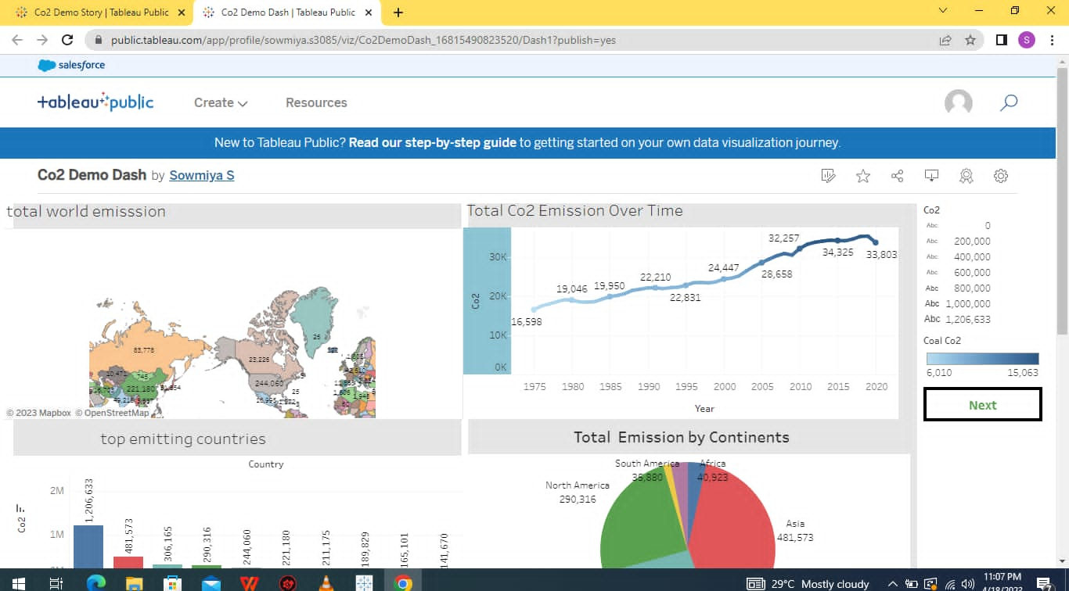

**4. ADVANTAGES & DISADVANTAGES**

**ADVANTAGES:**

1.Green plants grow faster with more Co2.

2.Many also become higher Co2 levels allow plants to use water more

Efficiently.

3. More abundant vegetation from increased Co2 is already apparent.

**DISADVANTAGES:**

1.Co2 is one of the Toxic gas.

2.Co2 increase the earth temperature and so global Warming.

3.Increase in percentage of Co2 in air causes melting of Snow and hence

There are increase in sea Water level.

**APPLICATIONS**

Food and beverage production, metal fabrication, cooling, fire suppression

And stimulating plant growth in greenhouses. Most commercial applications

Today involve direct use of Co2. New pathways involve transforming Co2 into

Fuels, Chemicals and buildings materials. The Carbon stored in naturals sinks

Such as forests is released into the Atmosphere through forest fires, changes in

Land use or logging.

**6.CONCLUSION**

The rising level of Atmospheric Co2 could be the one global natural

Resources that is progressively increasing food production and total biological

Output, in a world of other diminishing natural resources of Land, Water,

Energy, and Fertilizer. This shows that Co2 is essential for

Photosynthesis , because the portion inside the bottle did not get the Co2

As it was adsorbed by KOH solution.

**7.FUTURE SCOPE**

In the Annual Energy Outllok 2022 (AEO2022) Reference case, which assumes

no changes to current laws or regulations, the U.S. Energy Information

Administration (EIA) projects that U.S. energy-related Carbon dioxide (co2)

Emissions will fall to 4.5 billion metric tons in 2037, or 6% below the energy

Related Co2.

**8.APPENDIX**

1.Tableau

2.Tableau dashboard

3.Tableau Story

4.Tableau public